Business Requirement Document
14 June 2025
01:04 PM

Project Title
Real-Time Fraud Detection & Notification System

Objective / Purpose
To develop a real-time fraud detection system that monitors financial transactions, detects suspicious patterns using predefined rules, and immediately notifies users via email and SMS. This system will be scalable, event-driven, and suitable for use in digital banking, fintech platforms, or payment systems.

Background / Problem Statement
Digital transactions are increasing rapidly, and with them, the risk of fraudulent activities. Traditional batch fraud checks introduce delay and risk. There is a business need for a real-time, event-based fraud detection system that can immediately flag suspicious activity and notify the user, allowing them to take instant action.

Business Goals
Goal ID | Goal Description
G1 | Detect suspicious transactions using fraud rules
G2 | Notify users via SMS/Email when fraud is detected
G3 | Enable real-time monitoring through a web dashboard
G4 | Provide an auditable history of flagged transactions and user notifications
G5 | Ensure the system is scalable, loosely coupled, and cloud-deployable

Scope
In Scope:
- Kafka-based transaction stream processing
- Fraud rule engine (basic and extendable)
- Kafka producers/consumers
- Email and SMS notification integration
- PostgreSQL/MongoDB data persistence
- Admin dashboard with real-time alerts (WebSocket/SSE)
- Dockerized local setup
Out of Scope:
- Machine Learning/AI-based fraud prediction (can be future enhancement)
- Payment gateway integration
- Customer onboarding/KYC

Stakeholders
Role | Responsibility
Business Analyst | Define rules, document requirements
Developer | Build services, integrate APIs
QA Engineer | Test transaction flow and fraud rules
DevOps | Handle deployment (local or cloud)
End User | Receives alerts for suspicious activity

Functional Requirements
FR No. | Description
FR1 | The system shall accept transaction data via a Kafka producer
FR2 | The system shall apply fraud detection rules in real-time
FR3 | The system shall publish flagged transactions to a Kafka topic
FR4 | The system shall notify users via email and SMS when fraud is detected
FR5 | The system shall persist flagged transactions and notifications to DB
FR6 | The system shall expose REST APIs for viewing transaction and alert data
FR7 | The system shall provide a web dashboard for real-time monitoring

Non-Functional Requirements
NFR No. | Requirement
NFR1 | System should handle at least 1000 transactions/sec
NFR2 | System should deliver notifications in <5 seconds
NFR3 | System should be modular and containerized
NFR4 | All sensitive data must be secured and encrypted
NFR5 | Dashboard must support real-time updates (WebSocket/SSE)

Data Flow Diagram

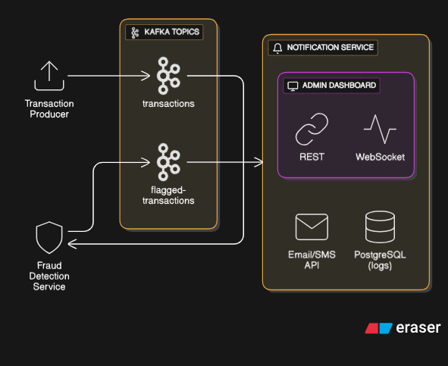

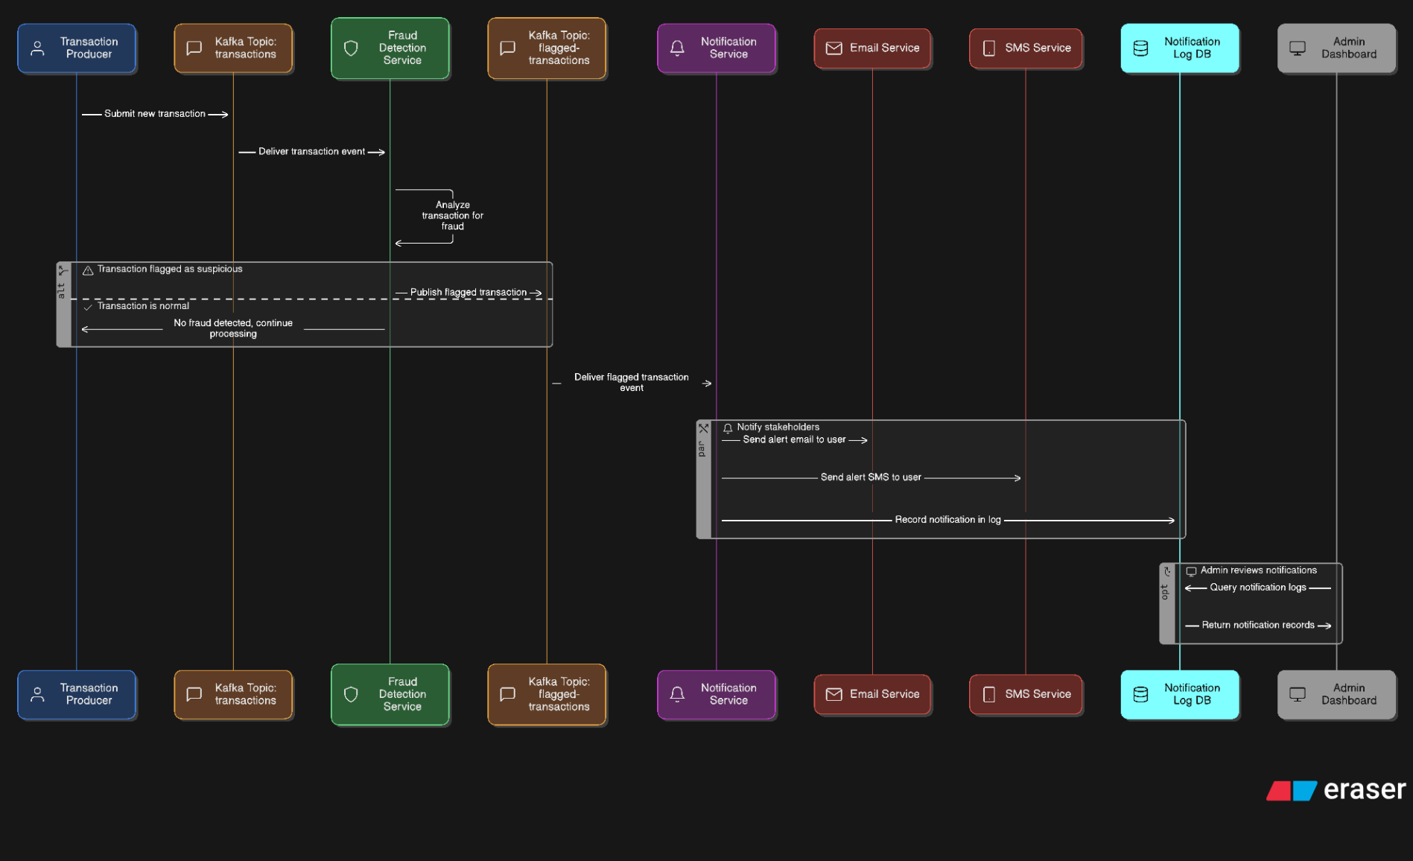

Technology Stack
Layer | Tech Stack
Backend | Java, Spring Boot, Spring Kafka, REST
Messaging | Apache Kafka
Database | PostgreSQL (preferred), MongoDB (optional)
Notification | Twilio (SMS), SendGrid (Email)
Frontend | React (preferred), Angular
Real-time UI | WebSocket or Server-Sent Events (SSE)
Deployment | Docker, Docker Compose

Milestones / Timeline
Week | Deliverable
1 | Project setup, Kafka producer/consumer, fraud rules
2 | Flagged transaction service, DB integration
3 | Email/SMS notification module, REST APIs
4 | Admin dashboard, Docker setup, testing, and polish

Assumptions
- User contact information is available in the system
- External APIs (SMS/Email) have been configured with valid API keys
- Kafka and database services are available during runtime

Future Enhancements
- ML-based fraud prediction engine
- Push notifications via mobile app
- Role-based access and analytics dashboard
- Historical fraud heatmaps and visualizations

Resume Highlight Suggestion
"Built a real-time fraud detection system using Kafka and Spring Boot with integrated user alerts via Twilio SMS and SendGrid Email APIs, supported by a real-time React dashboard and PostgreSQL persistence."

